NETWORKING & VIRTUAL LAB REPORT
Kali Linux and Metasploitable Connectivity Verification

Student Name:Safia Iftikhar
Internship @ Zyro
Date: 05 September 2026
Lab Environment: Oracle VirtualBox

1. Introduction
This report documents a virtual networking lab performed in Oracle VirtualBox using Kali Linux as the security-testing machine and Metasploitable as the intentionally vulnerable practice machine. The supplied evidence includes starting the virtual machines, checking network interfaces with ifconfig, identifying IP addressing information, performing a ping test, and viewing an ARP/network scan.

2. Objectives
- Verify that the required virtual machines are running in Oracle VirtualBox.
- Check the network configuration of the Metasploitable machine.
- Check the network configuration of the Kali Linux machine.
- Test IP-level connectivity using ping.
- Observe hosts discovered through ARP/network discovery.
- Evaluate whether the evidence conclusively proves Kali-to-Metasploitable connectivity.

3. Lab Environment
Component | Role | Evidence
Kali Linux | Testing / attack-side VM | Kali ifconfig screenshot
Metasploitable | Target / vulnerable VM | Metasploitable ifconfig screenshot
Oracle VirtualBox | Virtualization platform | VirtualBox Manager screenshot

4. Evidence and Observations
Virtual machine status: The VirtualBox Manager screenshot shows Kali Linux and Metasploitable as Running. Windows 10 is listed but powered off.
Metasploitable network configuration: The Metasploitable ifconfig output shows eth0 with IPv4 address 10.0.2.15 and subnet mask 255.255.255.0; the interface is UP and RUNNING.
Kali Linux network configuration: The Kali ifconfig output shows eth0 with IPv4 address 10.0.2.15 and subnet mask 255.255.255.0; the interface is UP, BROADCAST, RUNNING and MULTICAST.
Ping test: Kali runs ping -c 4 10.0.2.15 and receives 4 replies from 10.0.2.15, with 0% packet loss and very low response times.
ARP/network scan: The scan view reports completion and lists 10.0.2.2 and 10.0.2.3 as discovered hosts.

5. Important Technical Finding
IP-address conflict / verification issue: Both the Metasploitable and Kali screenshots visibly show the IPv4 address 10.0.2.15. If both VMs are intended to communicate on the same Layer-2 network, they should normally have different IP addresses. Therefore, the successful ping to 10.0.2.15 does not by itself prove that Kali reached Metasploitable; it may have reached Kali itself or another path.
Recommended correction: Verify that each VM has a unique IP address on the same isolated lab network (such as the VirtualBox network configuration required by your instructor), then repeat ifconfig, ping, and ARP discovery. Use the actual assigned addresses rather than assuming a particular address.

6. Step-by-Step Procedure
- Open Oracle VirtualBox and start Kali Linux and Metasploitable.
- On Metasploitable, run ifconfig and record the active Ethernet interface and IPv4 address.
- On Kali Linux, run ifconfig and record the active Ethernet interface and IPv4 address.
- From Kali Linux, run a controlled ping test using ping -c 4 <target-IP>.
- Run the required ARP/network discovery scan and observe the hosts reported.
- Compare discovered addresses with the addresses shown by ifconfig.
- If the two VMs have duplicate addresses or the target cannot be uniquely identified, correct the network configuration and repeat the tests.

7. Results
Test | Observed Result | Assessment
VM startup | Kali Linux and Metasploitable shown as Running | Successful
Metasploitable ifconfig | eth0: 10.0.2.15 / 255.255.255.0 | Recorded
Kali ifconfig | eth0: 10.0.2.15 / 255.255.255.0 | Recorded; duplicate address requires verification
Ping 10.0.2.15 | 4 transmitted, 4 received, 0% packet loss | Ping successful, but target identity not proven
ARP/network scan | 10.0.2.2 and 10.0.2.3 discovered | Scan completed; target VM not clearly identified

8. Conclusion
The supplied screenshots demonstrate that the virtual lab was launched, network interfaces were inspected, a ping command was completed successfully, and an ARP/network scan was performed. However, both Kali Linux and Metasploitable appear to use 10.0.2.15. Because of this duplicate address, the evidence should not be presented as definitive proof of Kali-to-Metasploitable connectivity. After assigning unique IP addresses on the same lab network and repeating the tests, the final submission will provide stronger and clearer evidence.

9. Screenshot Evidence
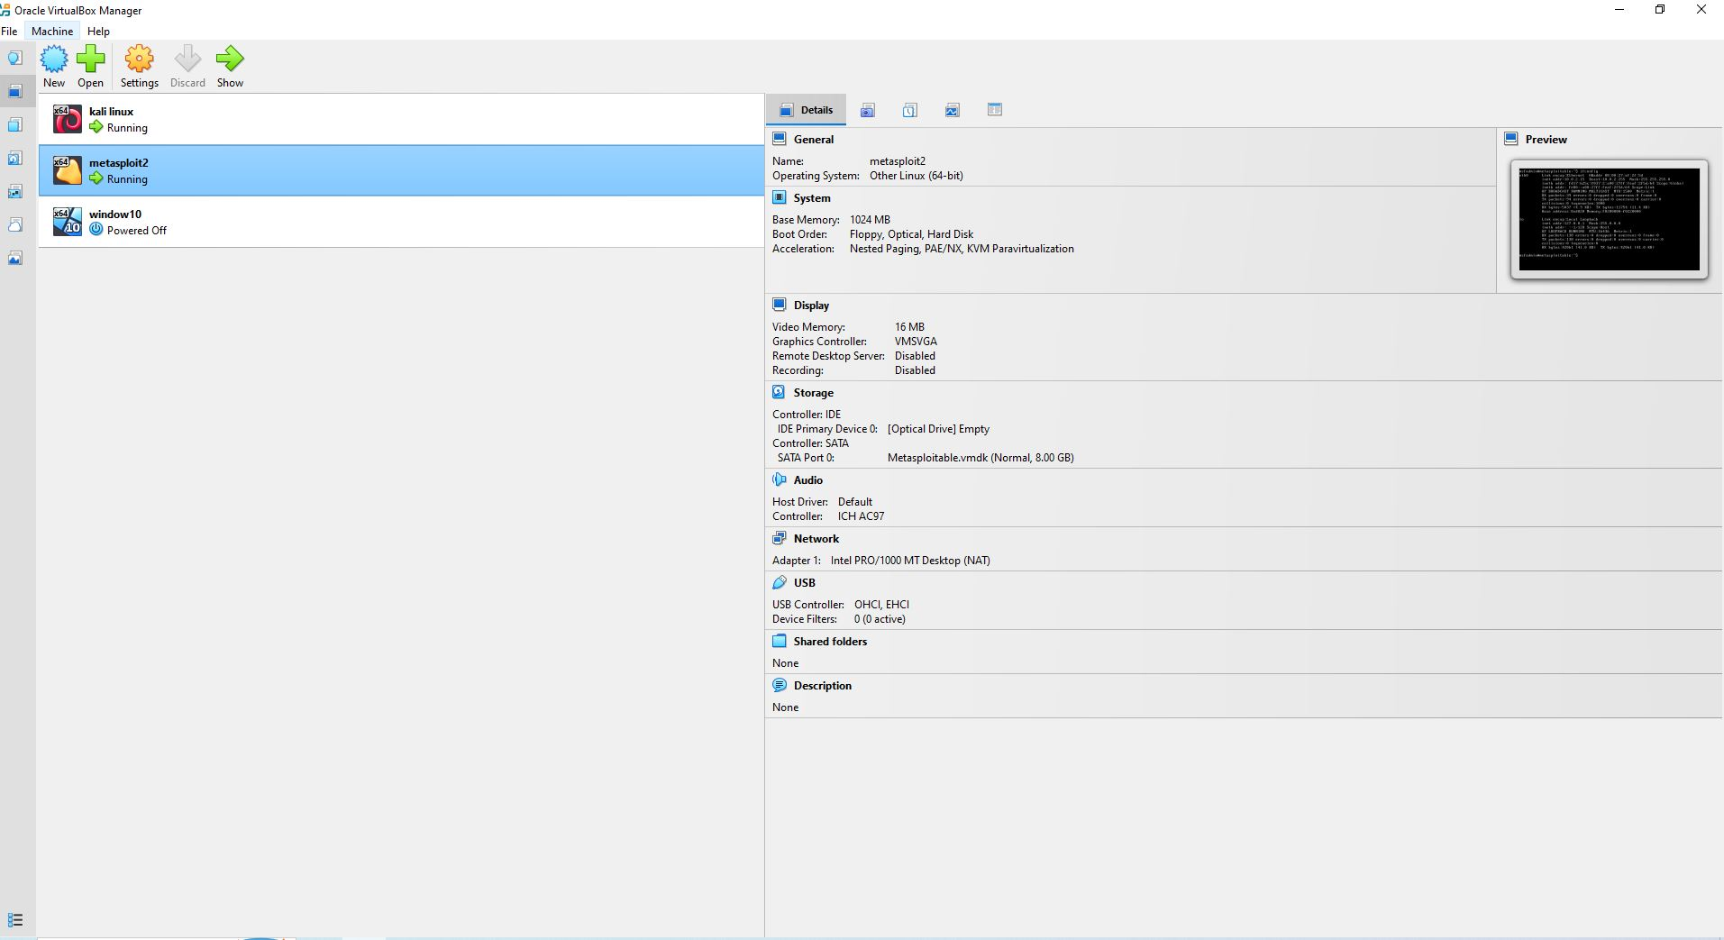
Figure 1: Oracle VirtualBox showing Kali Linux and Metasploitable virtual machines running.
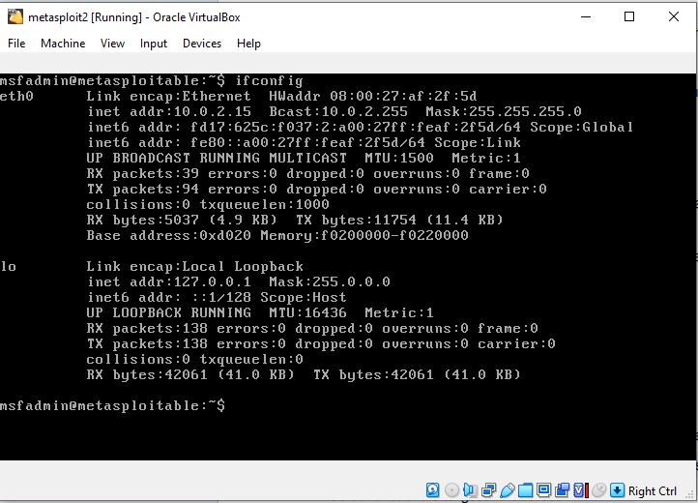
Figure 2: Metasploitable network configuration using ifconfig.
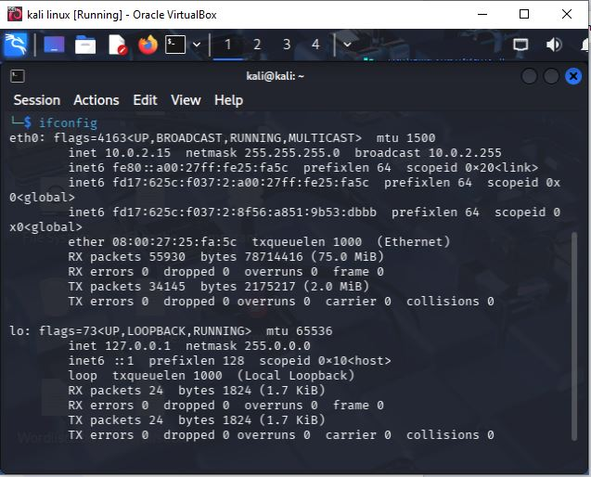
Figure 3: Kali Linux network configuration using ifconfig.
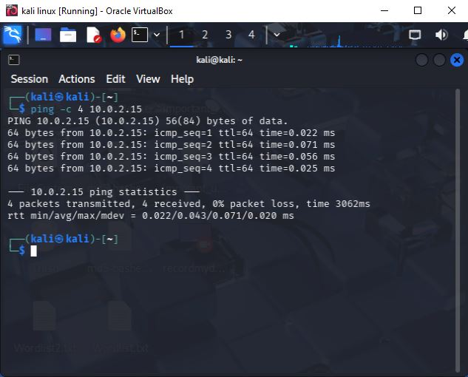
Figure 4: Kali Linux ping test to 10.0.2.15 showing four replies.
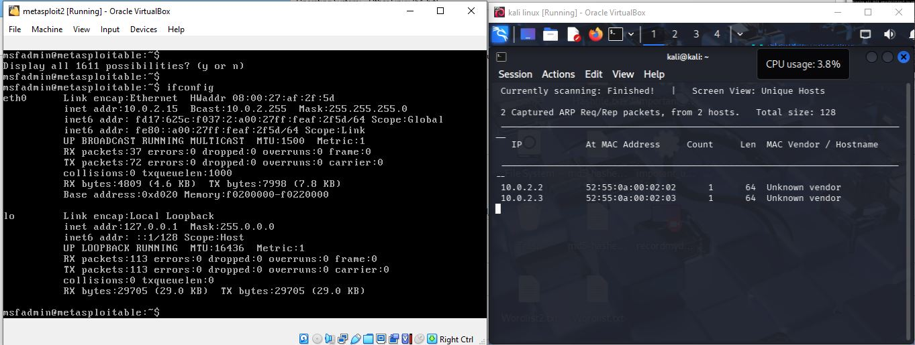
Figure 5: ARP/network scan view showing two discovered hosts (10.0.2.2 and 10.0.2.3).
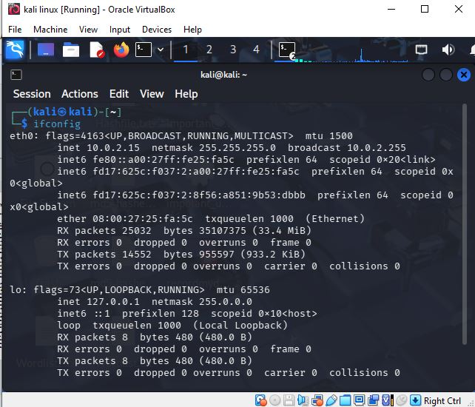
Figure 6: Kali Linux ifconfig output with interface and packet statistics.

10. Final Submission Checklist
☑ VirtualBox environment documented
☑ Kali Linux configuration documented
☑ Metasploitable configuration documented
☑ Ping result documented
☑ ARP/network scan documented
☑ Addressing inconsistency identified
☐ Verify unique IP addresses and repeat the target connectivity test

